The TorXakis Eclipse Plug-In

The TorXakis Eclipse Plug-In provides a specialized TorXakisDsl editor which helps you editing TorXakis model files. This specialized editor will show a TorXakis model with syntax highlighting and will show errors when something is wrong in the syntax of the model.

# Install the Plug-in

To install the TorXakis Eclipse Plug-in for the first time, carry out the following steps:

1. From the Eclipse “Help” menu select “Install New Software…”. The “Install” dialog appears.
2. Click the “Add…” button. The “Add Repository” dialog appears.
3. In the “Name” field enter “TorXakis Eclipse Plug-in”.
4. In the “Location” field enter

jar:https://github.com/TorXakis/SupportEclipse/releases/download/v1.0/update-site.zip!/

or

https://github.com/harcokuppens/TorXakisEclipsePluginUpdateSite/raw/master/

1. Click “*Open”*.
2. Click “OK”.
3. Uncheck “*Group items by category*” checkbox in lower section.
4. Click the “*TorXakisDsl Feature*” checkbox and click “*Next*” twice.
5. Accept the license agreement and click “Finish”. Wait while plug-in is being installed.
6. A “Security Warning” pop-up might appear. Click “OK” to continue installing the plug-in.
7. When the installation has finished a pop-up appears that asks to restart Eclipse. A restart is required to use the plug-in so click “Yes”.

# Check for updates

Updates of the TorXakis Eclipse Plug-in are distributed on the update site. The standard Eclipse “Check for updates” mechanism is used here:

1. From the Eclipse menu bar select “Help” 🡪 “Check for Updates”. If there are updates a dialog will pop-up.
2. Select the update and click “Next” twice.
3. Accept license agreement and click “Finish”. The plug-in will now be updated.
4. A “Security Warning” pop-up might appear. Click “OK” to continue installing the plug-in.
5. When the installation has finished a pop-up appears that asks to restart Eclipse. A restart is required to use the plug-in so click “Yes”.

# Testing the Plug-In

To test the plug-in do the following:

1. Run in a shell:   
    svn export https://github.com/TorXakis/SupportEclipse.git/trunk/test

Which downloads example torxakis models into a local folder test/ .

1. From the Eclipse “File” menu select “Import…”. The “Import” dialog appears.
2. Select “General 🡪 Existing Projects into Workspace” and click “Next”.
3. Click “Browse…”, the “Browse For Folder” dialog opens.
4. Select the folder test and click “Finish”.

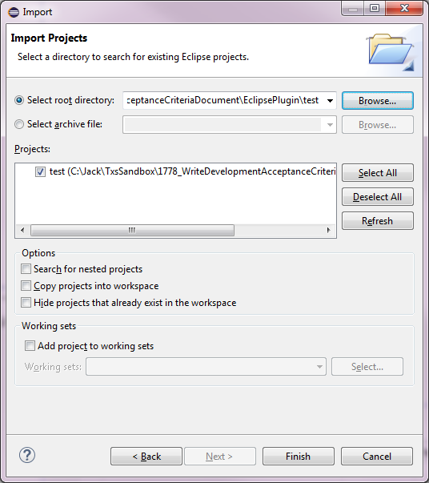

Figure 2: Importing the test project in the runtime Eclipse

1. The “test” project is now visible in the “Project Explorer”. Open the test folder and select all “.txs” files in it.

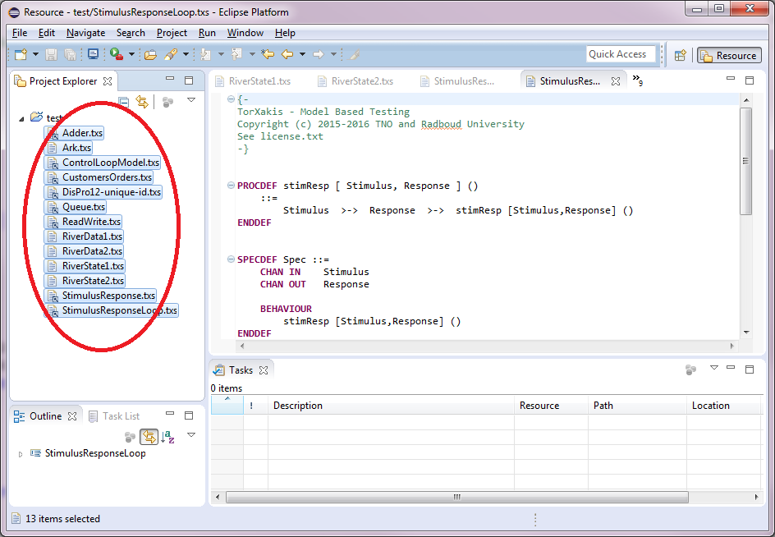

Figure 3: Selecting all TorXakis specifications

1. Right-click one of the selected files and select open. This will open editors for all .txs files.

The editor used for opening a .txs file is the specialized TorXakisDsl Editor installed with the TorXakis Eclipse Plug-In which show the TorXakis model with syntax highlighting and will show errors when something is wrong in the syntax of the model.

1. Now check that there are no errors in the file. If a red rectangle appears in front of the file name, there is an error in the plug-in. Consult the developer who made changes to the Eclipse Plug-in whether he has introduced an error.
2. When finished close the Eclipse runtime environment.